Process for Modifying a BISD Facility

Definitions
Facility Modification – Changes to a facility or a site that involve additions or removals of building or site components. (Examples would be the addition of a wall to divide a room, renovation of an existing classroom into offices, removal of lockers for collaboration space, addition of playground components addition of parking spaces or drive, removal of playground equipment and similar work.)

Facility Modification Request (FMR) form – document on which changes to a district facility or site are requested and processed through the FM department and approved at the Cabinet level. FMR forms are only submitted by the campus principal or facility director.

Process
- Principal or facility director receives request for a project.
- Principal or facility director completes the FMR form and submits it in the FM work request system to the Director of Facilities Management.
  - Access the support Portal at support.birdvilleschools.net
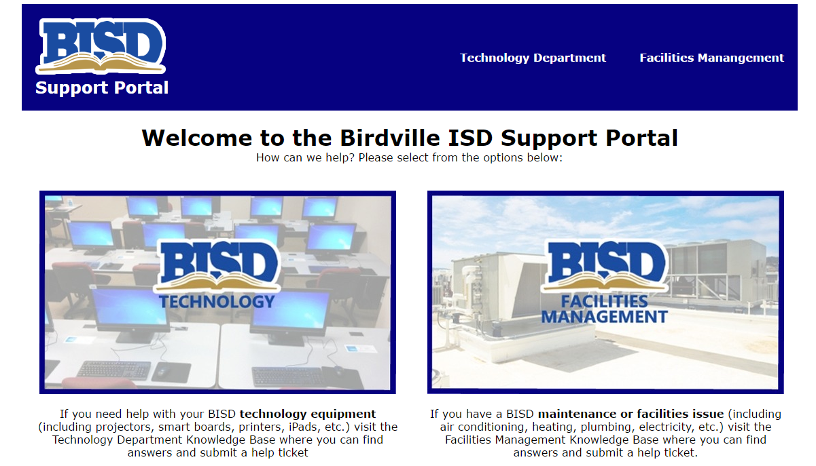
  - Click the Facilities Management icon
Click
  - Click the Facilities Modifications “Forms” Knowledge Base icon
Click
  - Click the “Facilities Modifications Request (FMR)” link and save the document to a file folder of your choice.
  - Complete the FMR.
  - Open a FM work request by clicking the red button found on the FM Knowledge Base page
Click
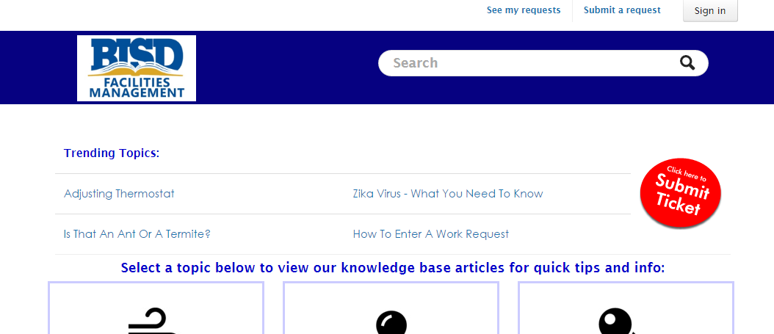

  - Complete the work request. 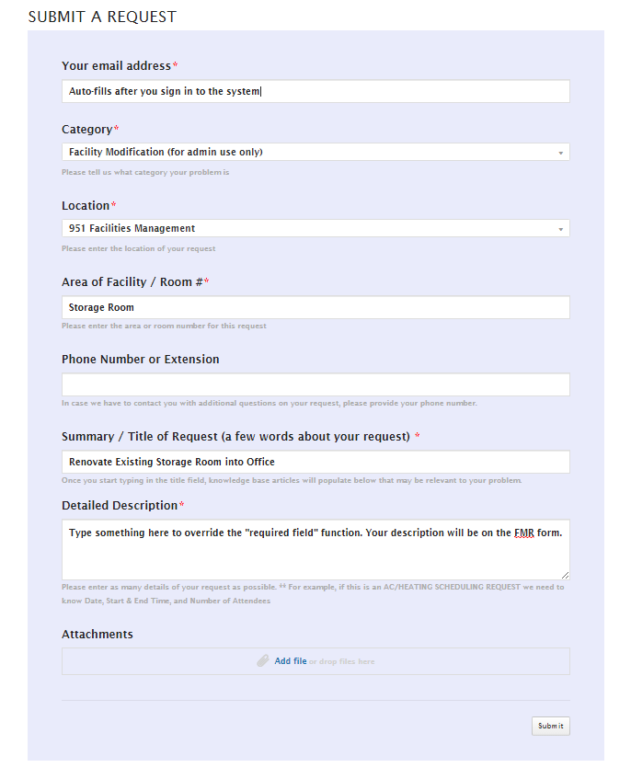
Drag completed FMR form here and click “submit”.
  - FM receives the request with FMR and assigns the project to a project manager, who will contact the requestor and obtain any additional information about the project. Project costs will be estimated

